**Program Structures & Algorithms  
Spring 2022  
Assignment No. 4**

**Name: Ajay Kumar Reddy Nelavetla**

**(NUID):002924033**

**Task**

* Implement a parallel sorting algorithm such that each partition of the array is sorted in parallel. You will consider two different schemes for deciding whether to sort in parallel.
* (Part 1) A cutoff (defaults to, say, 1000) which you will update according to the first argument in the command line when running. It's your job to experiment and come up with a good value for this cutoff. If there are fewer elements to sort than the cutoff, then you should use the system sort instead.
* (Part 2) Recursion depth or the number of available threads. Using this determination, you might decide on an ideal number (t) of separate threads (stick to powers of 2) and arrange for that number of partitions to be parallelized (by preventing recursion after the depth of lg t is reached).
* (Part 3) Implement a main program to run the following benchmarks: measure the running times of this sort.
* Show the results of your experiments and draws a conclusion (or more) about the efficacy of this method of parallelizing sort.
* Experiments should involve sorting arrays of sufficient size for the parallel sort to make a difference. You should run with many different array sizes (they must be sufficiently large to make parallel sorting worthwhile, obviously) and different cutoff schemes.

**Relationship Conclusion**

I ran many experiments changing values of cutoff, size of array and number of threads doing the parallel sort.

After seeing the graph and data of experiment, I think it is optimal to use 4 threads to do parallel sort. If we increase the number of threads more than 4 then the run time does not change much and is similar.

The run time was minimum when the cut off value is 25% of the array length.

So we have concluded with these expressions out of this experiment.

For recursion depth and number of threads available

Maximum depth possible:

**Evidence to the Conclusion**

Below are the runtimes in ‘ms’ for different combinations of Array size, threads, and cutoffs.

Array size = 400000

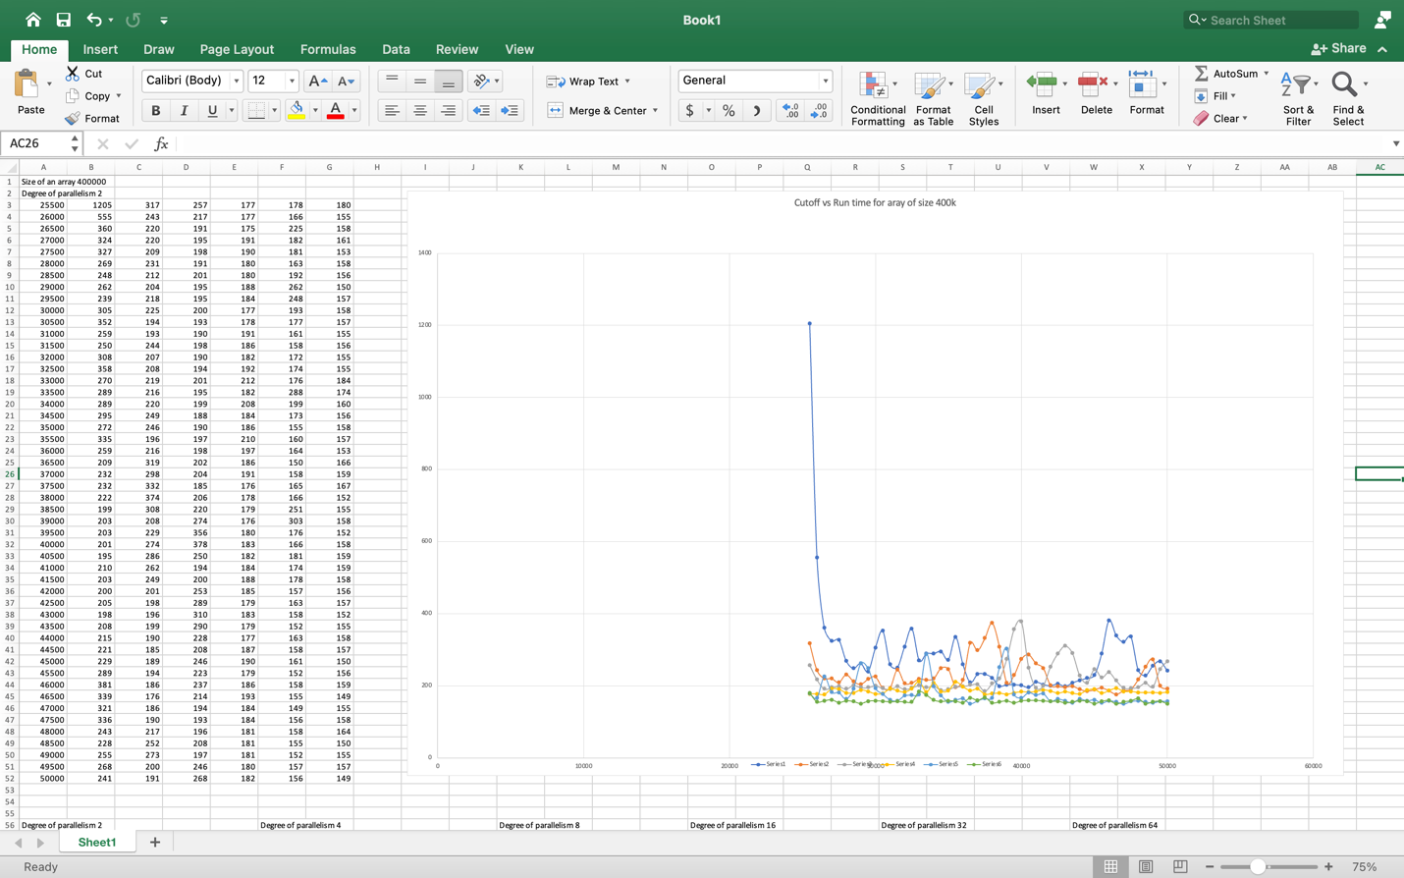

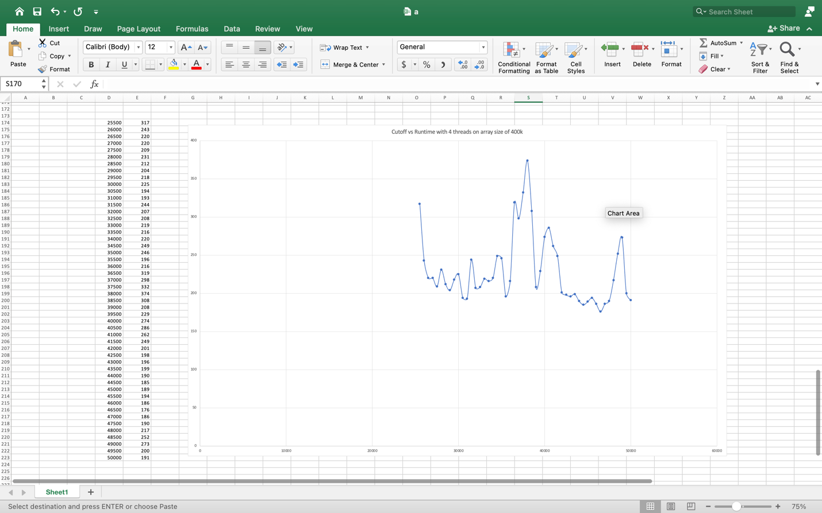

Array size = 800000

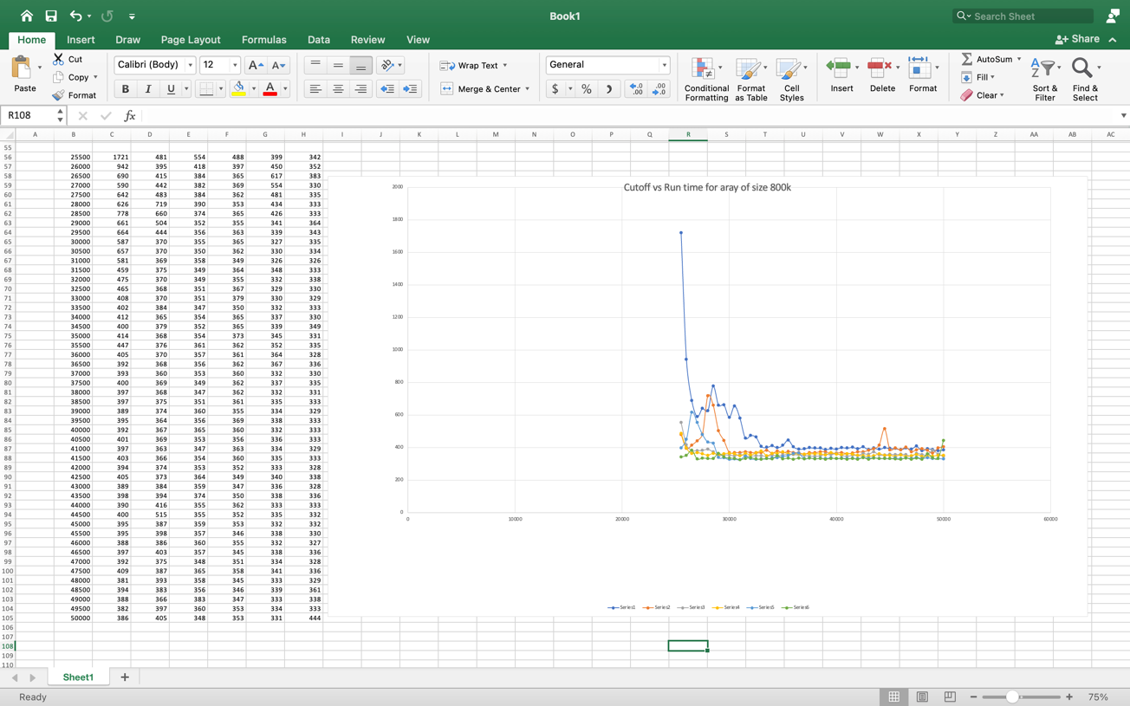

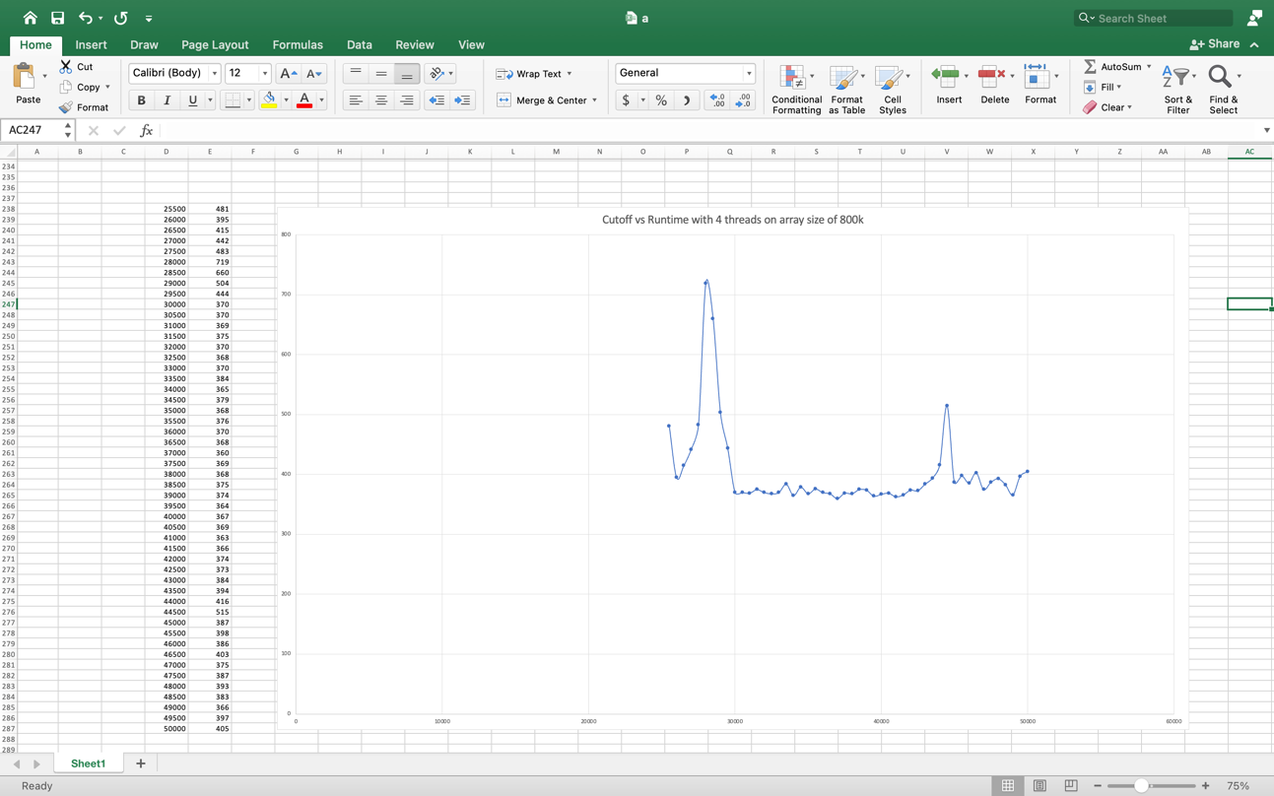

Array size = 1600000

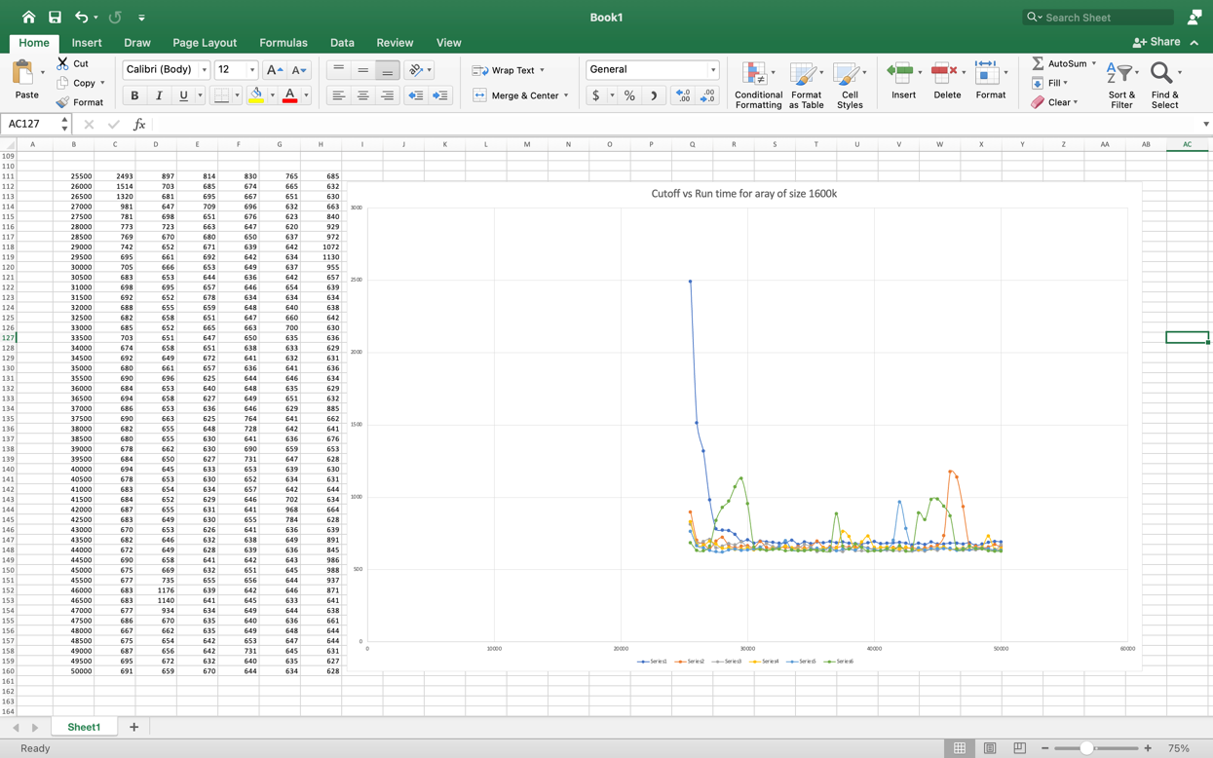

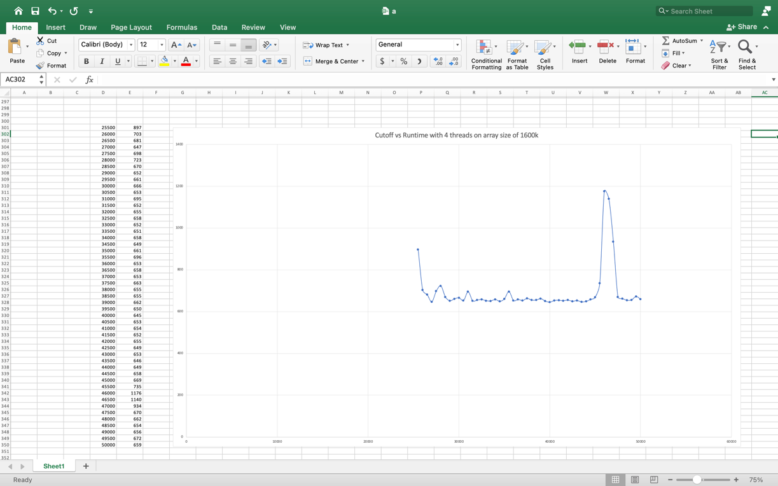

**Output Screenshot**

Array size = 400000

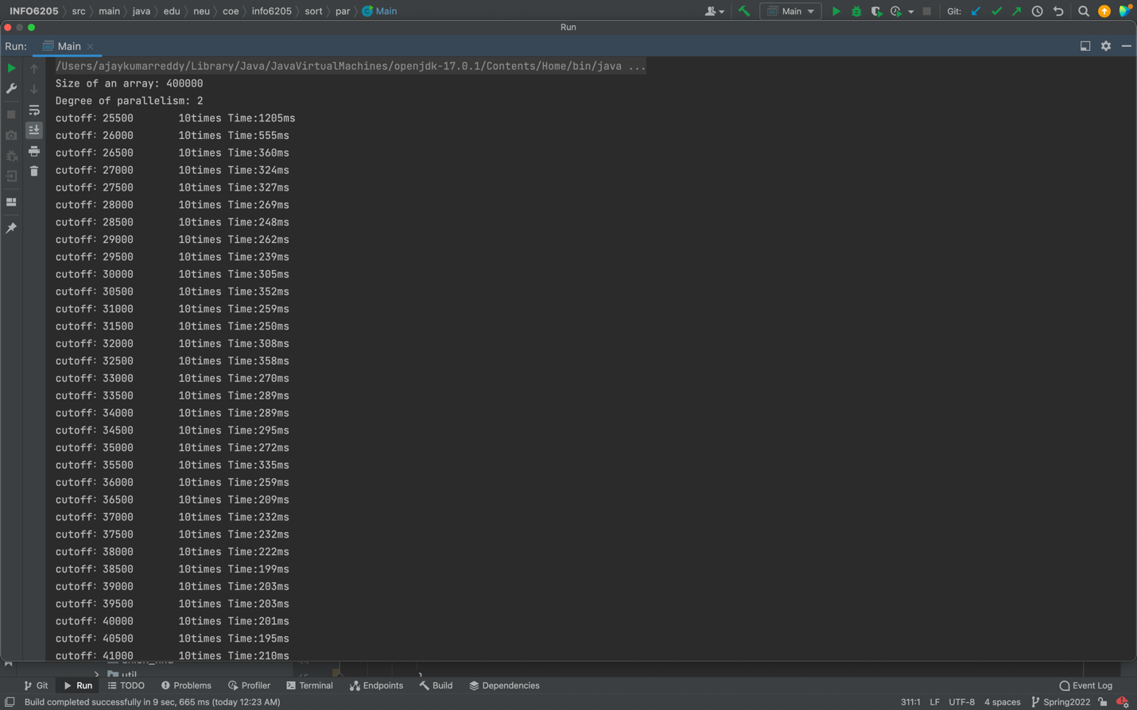

Array size = 800000

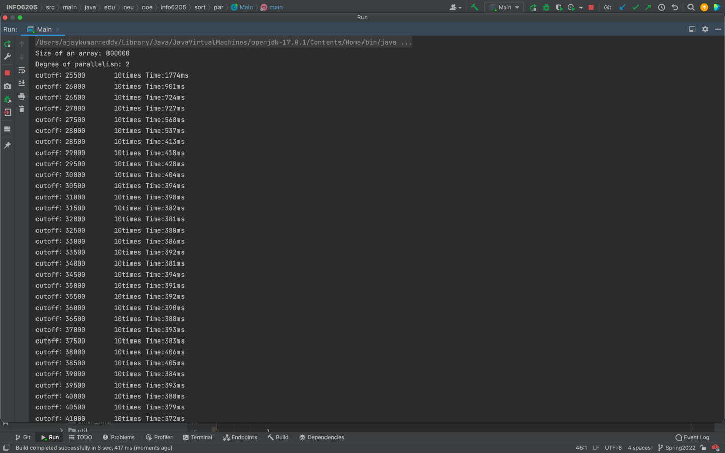

Array size = 1600000

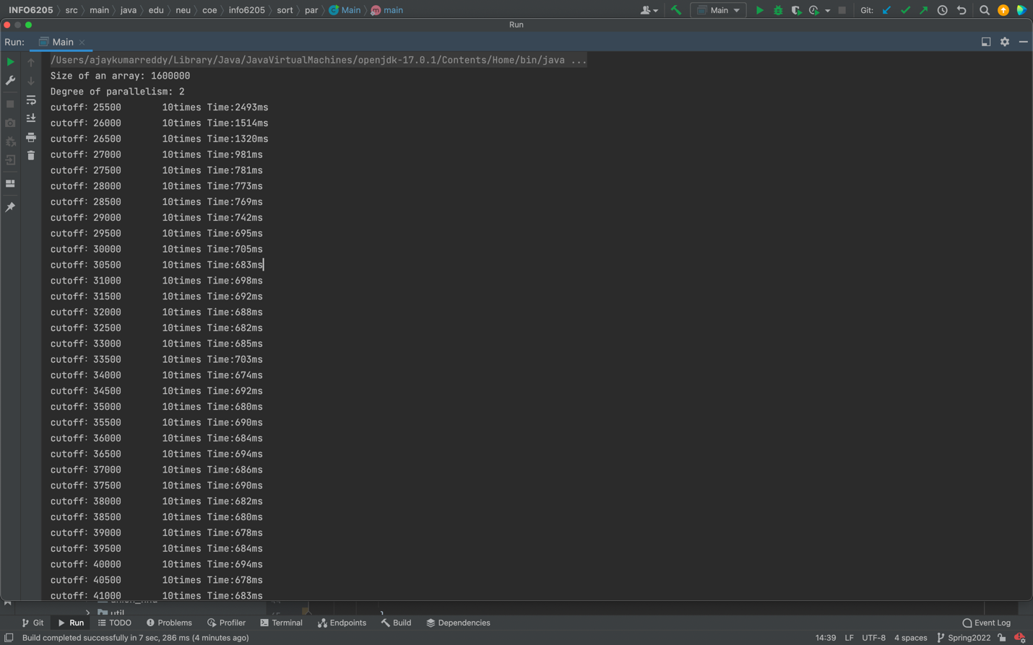

**Output**

Size of an array: 400000

Degree of parallelism: 2

cutoff：25500 10times Time:1205ms

cutoff：26000 10times Time:555ms

cutoff：26500 10times Time:360ms

cutoff：27000 10times Time:324ms

cutoff：27500 10times Time:327ms

cutoff：28000 10times Time:269ms

cutoff：28500 10times Time:248ms

cutoff：29000 10times Time:262ms

cutoff：29500 10times Time:239ms

cutoff：30000 10times Time:305ms

cutoff：30500 10times Time:352ms

cutoff：31000 10times Time:259ms

cutoff：31500 10times Time:250ms

cutoff：32000 10times Time:308ms

cutoff：32500 10times Time:358ms

cutoff：33000 10times Time:270ms

cutoff：33500 10times Time:289ms

cutoff：34000 10times Time:289ms

cutoff：34500 10times Time:295ms

cutoff：35000 10times Time:272ms

cutoff：35500 10times Time:335ms

cutoff：36000 10times Time:259ms

cutoff：36500 10times Time:209ms

cutoff：37000 10times Time:232ms

cutoff：37500 10times Time:232ms

cutoff：38000 10times Time:222ms

cutoff：38500 10times Time:199ms

cutoff：39000 10times Time:203ms

cutoff：39500 10times Time:203ms

cutoff：40000 10times Time:201ms

cutoff：40500 10times Time:195ms

cutoff：41000 10times Time:210ms

cutoff：41500 10times Time:203ms

cutoff：42000 10times Time:200ms

cutoff：42500 10times Time:205ms

cutoff：43000 10times Time:198ms

cutoff：43500 10times Time:208ms

cutoff：44000 10times Time:215ms

cutoff：44500 10times Time:221ms

cutoff：45000 10times Time:229ms

cutoff：45500 10times Time:289ms

cutoff：46000 10times Time:381ms

cutoff：46500 10times Time:339ms

cutoff：47000 10times Time:321ms

cutoff：47500 10times Time:336ms

cutoff：48000 10times Time:243ms

cutoff：48500 10times Time:228ms

cutoff：49000 10times Time:255ms

cutoff：49500 10times Time:268ms

cutoff：50000 10times Time:241ms

Degree of parallelism: 4

cutoff：25500 10times Time:317ms

cutoff：26000 10times Time:243ms

cutoff：26500 10times Time:220ms

cutoff：27000 10times Time:220ms

cutoff：27500 10times Time:209ms

cutoff：28000 10times Time:231ms

cutoff：28500 10times Time:212ms

cutoff：29000 10times Time:204ms

cutoff：29500 10times Time:218ms

cutoff：30000 10times Time:225ms

cutoff：30500 10times Time:194ms

cutoff：31000 10times Time:193ms

cutoff：31500 10times Time:244ms

cutoff：32000 10times Time:207ms

cutoff：32500 10times Time:208ms

cutoff：33000 10times Time:219ms

cutoff：33500 10times Time:216ms

cutoff：34000 10times Time:220ms

cutoff：34500 10times Time:249ms

cutoff：35000 10times Time:246ms

cutoff：35500 10times Time:196ms

cutoff：36000 10times Time:216ms

cutoff：36500 10times Time:319ms

cutoff：37000 10times Time:298ms

cutoff：37500 10times Time:332ms

cutoff：38000 10times Time:374ms

cutoff：38500 10times Time:308ms

cutoff：39000 10times Time:208ms

cutoff：39500 10times Time:229ms

cutoff：40000 10times Time:274ms

cutoff：40500 10times Time:286ms

cutoff：41000 10times Time:262ms

cutoff：41500 10times Time:249ms

cutoff：42000 10times Time:201ms

cutoff：42500 10times Time:198ms

cutoff：43000 10times Time:196ms

cutoff：43500 10times Time:199ms

cutoff：44000 10times Time:190ms

cutoff：44500 10times Time:185ms

cutoff：45000 10times Time:189ms

cutoff：45500 10times Time:194ms

cutoff：46000 10times Time:186ms

cutoff：46500 10times Time:176ms

cutoff：47000 10times Time:186ms

cutoff：47500 10times Time:190ms

cutoff：48000 10times Time:217ms

cutoff：48500 10times Time:252ms

cutoff：49000 10times Time:273ms

cutoff：49500 10times Time:200ms

cutoff：50000 10times Time:191ms

Degree of parallelism: 8

cutoff：25500 10times Time:257ms

cutoff：26000 10times Time:217ms

cutoff：26500 10times Time:191ms

cutoff：27000 10times Time:195ms

cutoff：27500 10times Time:198ms

cutoff：28000 10times Time:191ms

cutoff：28500 10times Time:201ms

cutoff：29000 10times Time:195ms

cutoff：29500 10times Time:195ms

cutoff：30000 10times Time:200ms

cutoff：30500 10times Time:193ms

cutoff：31000 10times Time:190ms

cutoff：31500 10times Time:198ms

cutoff：32000 10times Time:190ms

cutoff：32500 10times Time:194ms

cutoff：33000 10times Time:201ms

cutoff：33500 10times Time:195ms

cutoff：34000 10times Time:199ms

cutoff：34500 10times Time:188ms

cutoff：35000 10times Time:190ms

cutoff：35500 10times Time:197ms

cutoff：36000 10times Time:198ms

cutoff：36500 10times Time:202ms

cutoff：37000 10times Time:204ms

cutoff：37500 10times Time:185ms

cutoff：38000 10times Time:206ms

cutoff：38500 10times Time:220ms

cutoff：39000 10times Time:274ms

cutoff：39500 10times Time:356ms

cutoff：40000 10times Time:378ms

cutoff：40500 10times Time:250ms

cutoff：41000 10times Time:194ms

cutoff：41500 10times Time:200ms

cutoff：42000 10times Time:253ms

cutoff：42500 10times Time:289ms

cutoff：43000 10times Time:310ms

cutoff：43500 10times Time:290ms

cutoff：44000 10times Time:228ms

cutoff：44500 10times Time:208ms

cutoff：45000 10times Time:246ms

cutoff：45500 10times Time:223ms

cutoff：46000 10times Time:237ms

cutoff：46500 10times Time:214ms

cutoff：47000 10times Time:194ms

cutoff：47500 10times Time:193ms

cutoff：48000 10times Time:196ms

cutoff：48500 10times Time:208ms

cutoff：49000 10times Time:197ms

cutoff：49500 10times Time:246ms

cutoff：50000 10times Time:268ms

Degree of parallelism: 16

cutoff：25500 10times Time:177ms

cutoff：26000 10times Time:177ms

cutoff：26500 10times Time:175ms

cutoff：27000 10times Time:191ms

cutoff：27500 10times Time:190ms

cutoff：28000 10times Time:180ms

cutoff：28500 10times Time:180ms

cutoff：29000 10times Time:188ms

cutoff：29500 10times Time:184ms

cutoff：30000 10times Time:177ms

cutoff：30500 10times Time:178ms

cutoff：31000 10times Time:191ms

cutoff：31500 10times Time:186ms

cutoff：32000 10times Time:182ms

cutoff：32500 10times Time:192ms

cutoff：33000 10times Time:212ms

cutoff：33500 10times Time:182ms

cutoff：34000 10times Time:208ms

cutoff：34500 10times Time:184ms

cutoff：35000 10times Time:186ms

cutoff：35500 10times Time:210ms

cutoff：36000 10times Time:197ms

cutoff：36500 10times Time:186ms

cutoff：37000 10times Time:191ms

cutoff：37500 10times Time:176ms

cutoff：38000 10times Time:178ms

cutoff：38500 10times Time:179ms

cutoff：39000 10times Time:176ms

cutoff：39500 10times Time:180ms

cutoff：40000 10times Time:183ms

cutoff：40500 10times Time:182ms

cutoff：41000 10times Time:184ms

cutoff：41500 10times Time:188ms

cutoff：42000 10times Time:185ms

cutoff：42500 10times Time:179ms

cutoff：43000 10times Time:183ms

cutoff：43500 10times Time:179ms

cutoff：44000 10times Time:177ms

cutoff：44500 10times Time:187ms

cutoff：45000 10times Time:190ms

cutoff：45500 10times Time:179ms

cutoff：46000 10times Time:186ms

cutoff：46500 10times Time:193ms

cutoff：47000 10times Time:184ms

cutoff：47500 10times Time:184ms

cutoff：48000 10times Time:181ms

cutoff：48500 10times Time:181ms

cutoff：49000 10times Time:181ms

cutoff：49500 10times Time:180ms

cutoff：50000 10times Time:182ms

Degree of parallelism: 32

cutoff：25500 10times Time:178ms

cutoff：26000 10times Time:166ms

cutoff：26500 10times Time:225ms

cutoff：27000 10times Time:182ms

cutoff：27500 10times Time:181ms

cutoff：28000 10times Time:163ms

cutoff：28500 10times Time:192ms

cutoff：29000 10times Time:262ms

cutoff：29500 10times Time:248ms

cutoff：30000 10times Time:193ms

cutoff：30500 10times Time:177ms

cutoff：31000 10times Time:161ms

cutoff：31500 10times Time:158ms

cutoff：32000 10times Time:172ms

cutoff：32500 10times Time:174ms

cutoff：33000 10times Time:176ms

cutoff：33500 10times Time:288ms

cutoff：34000 10times Time:199ms

cutoff：34500 10times Time:173ms

cutoff：35000 10times Time:155ms

cutoff：35500 10times Time:160ms

cutoff：36000 10times Time:164ms

cutoff：36500 10times Time:150ms

cutoff：37000 10times Time:158ms

cutoff：37500 10times Time:165ms

cutoff：38000 10times Time:166ms

cutoff：38500 10times Time:251ms

cutoff：39000 10times Time:303ms

cutoff：39500 10times Time:176ms

cutoff：40000 10times Time:166ms

cutoff：40500 10times Time:181ms

cutoff：41000 10times Time:174ms

cutoff：41500 10times Time:178ms

cutoff：42000 10times Time:157ms

cutoff：42500 10times Time:163ms

cutoff：43000 10times Time:158ms

cutoff：43500 10times Time:152ms

cutoff：44000 10times Time:163ms

cutoff：44500 10times Time:158ms

cutoff：45000 10times Time:161ms

cutoff：45500 10times Time:152ms

cutoff：46000 10times Time:158ms

cutoff：46500 10times Time:155ms

cutoff：47000 10times Time:149ms

cutoff：47500 10times Time:156ms

cutoff：48000 10times Time:158ms

cutoff：48500 10times Time:155ms

cutoff：49000 10times Time:152ms

cutoff：49500 10times Time:157ms

cutoff：50000 10times Time:156ms

Degree of parallelism: 64

cutoff：25500 10times Time:180ms

cutoff：26000 10times Time:155ms

cutoff：26500 10times Time:158ms

cutoff：27000 10times Time:161ms

cutoff：27500 10times Time:153ms

cutoff：28000 10times Time:158ms

cutoff：28500 10times Time:156ms

cutoff：29000 10times Time:150ms

cutoff：29500 10times Time:157ms

cutoff：30000 10times Time:158ms

cutoff：30500 10times Time:157ms

cutoff：31000 10times Time:155ms

cutoff：31500 10times Time:156ms

cutoff：32000 10times Time:155ms

cutoff：32500 10times Time:155ms

cutoff：33000 10times Time:184ms

cutoff：33500 10times Time:174ms

cutoff：34000 10times Time:160ms

cutoff：34500 10times Time:156ms

cutoff：35000 10times Time:158ms

cutoff：35500 10times Time:157ms

cutoff：36000 10times Time:153ms

cutoff：36500 10times Time:166ms

cutoff：37000 10times Time:159ms

cutoff：37500 10times Time:167ms

cutoff：38000 10times Time:152ms

cutoff：38500 10times Time:155ms

cutoff：39000 10times Time:158ms

cutoff：39500 10times Time:152ms

cutoff：40000 10times Time:158ms

cutoff：40500 10times Time:159ms

cutoff：41000 10times Time:159ms

cutoff：41500 10times Time:158ms

cutoff：42000 10times Time:156ms

cutoff：42500 10times Time:157ms

cutoff：43000 10times Time:152ms

cutoff：43500 10times Time:155ms

cutoff：44000 10times Time:158ms

cutoff：44500 10times Time:157ms

cutoff：45000 10times Time:150ms

cutoff：45500 10times Time:156ms

cutoff：46000 10times Time:159ms

cutoff：46500 10times Time:149ms

cutoff：47000 10times Time:155ms

cutoff：47500 10times Time:158ms

cutoff：48000 10times Time:164ms

cutoff：48500 10times Time:150ms

cutoff：49000 10times Time:155ms

cutoff：49500 10times Time:157ms

cutoff：50000 10times Time:149ms

Size of an array: 800000

Degree of parallelism: 2

cutoff：25500 10times Time:1538ms

cutoff：26000 10times Time:782ms

cutoff：26500 10times Time:467ms

cutoff：27000 10times Time:401ms

cutoff：27500 10times Time:394ms

cutoff：28000 10times Time:399ms

cutoff：28500 10times Time:403ms

cutoff：29000 10times Time:381ms

cutoff：29500 10times Time:397ms

cutoff：30000 10times Time:370ms

cutoff：30500 10times Time:363ms

cutoff：31000 10times Time:366ms

cutoff：31500 10times Time:367ms

cutoff：32000 10times Time:369ms

cutoff：32500 10times Time:365ms

cutoff：33000 10times Time:363ms

cutoff：33500 10times Time:364ms

cutoff：34000 10times Time:365ms

cutoff：34500 10times Time:370ms

cutoff：35000 10times Time:382ms

cutoff：35500 10times Time:392ms

cutoff：36000 10times Time:384ms

cutoff：36500 10times Time:381ms

cutoff：37000 10times Time:381ms

cutoff：37500 10times Time:381ms

cutoff：38000 10times Time:383ms

cutoff：38500 10times Time:382ms

cutoff：39000 10times Time:395ms

cutoff：39500 10times Time:383ms

cutoff：40000 10times Time:358ms

cutoff：40500 10times Time:372ms

cutoff：41000 10times Time:372ms

cutoff：41500 10times Time:368ms

cutoff：42000 10times Time:381ms

cutoff：42500 10times Time:369ms

cutoff：43000 10times Time:372ms

cutoff：43500 10times Time:375ms

cutoff：44000 10times Time:369ms

cutoff：44500 10times Time:381ms

cutoff：45000 10times Time:372ms

cutoff：45500 10times Time:368ms

cutoff：46000 10times Time:372ms

cutoff：46500 10times Time:375ms

cutoff：47000 10times Time:367ms

cutoff：47500 10times Time:373ms

cutoff：48000 10times Time:375ms

cutoff：48500 10times Time:383ms

cutoff：49000 10times Time:371ms

cutoff：49500 10times Time:372ms

cutoff：50000 10times Time:372ms

Degree of parallelism: 4

cutoff：25500 10times Time:442ms

cutoff：26000 10times Time:420ms

cutoff：26500 10times Time:389ms

cutoff：27000 10times Time:384ms

cutoff：27500 10times Time:363ms

cutoff：28000 10times Time:398ms

cutoff：28500 10times Time:352ms

cutoff：29000 10times Time:365ms

cutoff：29500 10times Time:349ms

cutoff：30000 10times Time:362ms

cutoff：30500 10times Time:373ms

cutoff：31000 10times Time:363ms

cutoff：31500 10times Time:415ms

cutoff：32000 10times Time:550ms

cutoff：32500 10times Time:618ms

cutoff：33000 10times Time:593ms

cutoff：33500 10times Time:641ms

cutoff：34000 10times Time:674ms

cutoff：34500 10times Time:842ms

cutoff：35000 10times Time:704ms

cutoff：35500 10times Time:833ms

cutoff：36000 10times Time:643ms

cutoff：36500 10times Time:617ms

cutoff：37000 10times Time:719ms

cutoff：37500 10times Time:578ms

cutoff：38000 10times Time:579ms

cutoff：38500 10times Time:601ms

cutoff：39000 10times Time:556ms

cutoff：39500 10times Time:543ms

cutoff：40000 10times Time:511ms

cutoff：40500 10times Time:450ms

cutoff：41000 10times Time:497ms

cutoff：41500 10times Time:471ms

cutoff：42000 10times Time:385ms

cutoff：42500 10times Time:364ms

cutoff：43000 10times Time:350ms

cutoff：43500 10times Time:399ms

cutoff：44000 10times Time:417ms

cutoff：44500 10times Time:406ms

cutoff：45000 10times Time:429ms

cutoff：45500 10times Time:402ms

cutoff：46000 10times Time:374ms

cutoff：46500 10times Time:365ms

cutoff：47000 10times Time:371ms

cutoff：47500 10times Time:358ms

cutoff：48000 10times Time:352ms

cutoff：48500 10times Time:352ms

cutoff：49000 10times Time:354ms

cutoff：49500 10times Time:350ms

cutoff：50000 10times Time:363ms

Degree of parallelism: 8

cutoff：25500 10times Time:439ms

cutoff：26000 10times Time:397ms

cutoff：26500 10times Time:382ms

cutoff：27000 10times Time:355ms

cutoff：27500 10times Time:378ms

cutoff：28000 10times Time:344ms

cutoff：28500 10times Time:346ms

cutoff：29000 10times Time:334ms

cutoff：29500 10times Time:336ms

cutoff：30000 10times Time:338ms

cutoff：30500 10times Time:345ms

cutoff：31000 10times Time:337ms

cutoff：31500 10times Time:348ms

cutoff：32000 10times Time:350ms

cutoff：32500 10times Time:340ms

cutoff：33000 10times Time:336ms

cutoff：33500 10times Time:339ms

cutoff：34000 10times Time:333ms

cutoff：34500 10times Time:344ms

cutoff：35000 10times Time:336ms

cutoff：35500 10times Time:337ms

cutoff：36000 10times Time:333ms

cutoff：36500 10times Time:340ms

cutoff：37000 10times Time:338ms

cutoff：37500 10times Time:343ms

cutoff：38000 10times Time:343ms

cutoff：38500 10times Time:342ms

cutoff：39000 10times Time:332ms

cutoff：39500 10times Time:337ms

cutoff：40000 10times Time:329ms

cutoff：40500 10times Time:343ms

cutoff：41000 10times Time:341ms

cutoff：41500 10times Time:357ms

cutoff：42000 10times Time:374ms

cutoff：42500 10times Time:503ms

cutoff：43000 10times Time:442ms

cutoff：43500 10times Time:389ms

cutoff：44000 10times Time:346ms

cutoff：44500 10times Time:361ms

cutoff：45000 10times Time:343ms

cutoff：45500 10times Time:351ms

cutoff：46000 10times Time:541ms

cutoff：46500 10times Time:450ms

cutoff：47000 10times Time:486ms

cutoff：47500 10times Time:500ms

cutoff：48000 10times Time:506ms

cutoff：48500 10times Time:499ms

cutoff：49000 10times Time:488ms

cutoff：49500 10times Time:462ms

cutoff：50000 10times Time:586ms

Degree of parallelism: 16

cutoff：25500 10times Time:712ms

cutoff：26000 10times Time:568ms

cutoff：26500 10times Time:460ms

cutoff：27000 10times Time:501ms

cutoff：27500 10times Time:503ms

cutoff：28000 10times Time:550ms

cutoff：28500 10times Time:611ms

cutoff：29000 10times Time:588ms

cutoff：29500 10times Time:702ms

cutoff：30000 10times Time:503ms

cutoff：30500 10times Time:497ms

cutoff：31000 10times Time:415ms

cutoff：31500 10times Time:412ms

cutoff：32000 10times Time:433ms

cutoff：32500 10times Time:634ms

cutoff：33000 10times Time:576ms

cutoff：33500 10times Time:542ms

cutoff：34000 10times Time:433ms

cutoff：34500 10times Time:504ms

cutoff：35000 10times Time:470ms

cutoff：35500 10times Time:429ms

cutoff：36000 10times Time:444ms

cutoff：36500 10times Time:471ms

cutoff：37000 10times Time:479ms

cutoff：37500 10times Time:456ms

cutoff：38000 10times Time:497ms

cutoff：38500 10times Time:496ms

cutoff：39000 10times Time:501ms

cutoff：39500 10times Time:467ms

cutoff：40000 10times Time:415ms

cutoff：40500 10times Time:345ms

cutoff：41000 10times Time:353ms

cutoff：41500 10times Time:345ms

cutoff：42000 10times Time:333ms

cutoff：42500 10times Time:341ms

cutoff：43000 10times Time:338ms

cutoff：43500 10times Time:336ms

cutoff：44000 10times Time:344ms

cutoff：44500 10times Time:344ms

cutoff：45000 10times Time:334ms

cutoff：45500 10times Time:335ms

cutoff：46000 10times Time:343ms

cutoff：46500 10times Time:339ms

cutoff：47000 10times Time:339ms

cutoff：47500 10times Time:332ms

cutoff：48000 10times Time:342ms

cutoff：48500 10times Time:330ms

cutoff：49000 10times Time:345ms

cutoff：49500 10times Time:337ms

cutoff：50000 10times Time:338ms

Degree of parallelism: 32

cutoff：25500 10times Time:324ms

cutoff：26000 10times Time:308ms

cutoff：26500 10times Time:314ms

cutoff：27000 10times Time:312ms

cutoff：27500 10times Time:311ms

cutoff：28000 10times Time:310ms

cutoff：28500 10times Time:312ms

cutoff：29000 10times Time:320ms

cutoff：29500 10times Time:322ms

cutoff：30000 10times Time:313ms

cutoff：30500 10times Time:318ms

cutoff：31000 10times Time:309ms

cutoff：31500 10times Time:311ms

cutoff：32000 10times Time:311ms

cutoff：32500 10times Time:311ms

cutoff：33000 10times Time:320ms

cutoff：33500 10times Time:317ms

cutoff：34000 10times Time:310ms

cutoff：34500 10times Time:315ms

cutoff：35000 10times Time:316ms

cutoff：35500 10times Time:316ms

cutoff：36000 10times Time:311ms

cutoff：36500 10times Time:311ms

cutoff：37000 10times Time:313ms

cutoff：37500 10times Time:315ms

cutoff：38000 10times Time:311ms

cutoff：38500 10times Time:319ms

cutoff：39000 10times Time:311ms

cutoff：39500 10times Time:310ms

cutoff：40000 10times Time:349ms

cutoff：40500 10times Time:520ms

cutoff：41000 10times Time:429ms

cutoff：41500 10times Time:516ms

cutoff：42000 10times Time:497ms

cutoff：42500 10times Time:368ms

cutoff：43000 10times Time:411ms

cutoff：43500 10times Time:349ms

cutoff：44000 10times Time:322ms

cutoff：44500 10times Time:315ms

cutoff：45000 10times Time:313ms

cutoff：45500 10times Time:311ms

cutoff：46000 10times Time:307ms

cutoff：46500 10times Time:323ms

cutoff：47000 10times Time:316ms

cutoff：47500 10times Time:319ms

cutoff：48000 10times Time:309ms

cutoff：48500 10times Time:316ms

cutoff：49000 10times Time:344ms

cutoff：49500 10times Time:347ms

cutoff：50000 10times Time:312ms

Degree of parallelism: 64

cutoff：25500 10times Time:324ms

cutoff：26000 10times Time:308ms

cutoff：26500 10times Time:308ms

cutoff：27000 10times Time:312ms

cutoff：27500 10times Time:314ms

cutoff：28000 10times Time:307ms

cutoff：28500 10times Time:320ms

cutoff：29000 10times Time:309ms

cutoff：29500 10times Time:313ms

cutoff：30000 10times Time:307ms

cutoff：30500 10times Time:333ms

cutoff：31000 10times Time:324ms

cutoff：31500 10times Time:329ms

cutoff：32000 10times Time:311ms

cutoff：32500 10times Time:309ms

cutoff：33000 10times Time:306ms

cutoff：33500 10times Time:314ms

cutoff：34000 10times Time:307ms

cutoff：34500 10times Time:323ms

cutoff：35000 10times Time:354ms

cutoff：35500 10times Time:315ms

cutoff：36000 10times Time:314ms

cutoff：36500 10times Time:342ms

cutoff：37000 10times Time:320ms

cutoff：37500 10times Time:308ms

cutoff：38000 10times Time:311ms

cutoff：38500 10times Time:304ms

cutoff：39000 10times Time:304ms

cutoff：39500 10times Time:362ms

cutoff：40000 10times Time:324ms

cutoff：40500 10times Time:312ms

cutoff：41000 10times Time:305ms

cutoff：41500 10times Time:319ms

cutoff：42000 10times Time:310ms

cutoff：42500 10times Time:310ms

cutoff：43000 10times Time:307ms

cutoff：43500 10times Time:310ms

cutoff：44000 10times Time:307ms

cutoff：44500 10times Time:317ms

cutoff：45000 10times Time:306ms

cutoff：45500 10times Time:308ms

cutoff：46000 10times Time:303ms

cutoff：46500 10times Time:313ms

cutoff：47000 10times Time:305ms

cutoff：47500 10times Time:315ms

cutoff：48000 10times Time:305ms

cutoff：48500 10times Time:313ms

cutoff：49000 10times Time:318ms

cutoff：49500 10times Time:314ms

cutoff：50000 10times Time:311ms

Size of an array: 1600000

Degree of parallelism: 2

cutoff：25500 10times Time:3398ms

cutoff：26000 10times Time:1469ms

cutoff：26500 10times Time:1154ms

cutoff：27000 10times Time:1133ms

cutoff：27500 10times Time:1116ms

cutoff：28000 10times Time:1288ms

cutoff：28500 10times Time:1114ms

cutoff：29000 10times Time:1079ms

cutoff：29500 10times Time:949ms

cutoff：30000 10times Time:1048ms

cutoff：30500 10times Time:1532ms

cutoff：31000 10times Time:1269ms

cutoff：31500 10times Time:1073ms

cutoff：32000 10times Time:1215ms

cutoff：32500 10times Time:1088ms

cutoff：33000 10times Time:791ms

cutoff：33500 10times Time:986ms

cutoff：34000 10times Time:957ms

cutoff：34500 10times Time:929ms

cutoff：35000 10times Time:1074ms

cutoff：35500 10times Time:1060ms

cutoff：36000 10times Time:787ms

cutoff：36500 10times Time:852ms

cutoff：37000 10times Time:988ms

cutoff：37500 10times Time:900ms

cutoff：38000 10times Time:901ms

cutoff：38500 10times Time:964ms

cutoff：39000 10times Time:993ms

cutoff：39500 10times Time:1068ms

cutoff：40000 10times Time:795ms

cutoff：40500 10times Time:717ms

cutoff：41000 10times Time:698ms

cutoff：41500 10times Time:686ms

cutoff：42000 10times Time:693ms

cutoff：42500 10times Time:693ms

cutoff：43000 10times Time:693ms

cutoff：43500 10times Time:703ms

cutoff：44000 10times Time:771ms

cutoff：44500 10times Time:695ms

cutoff：45000 10times Time:711ms

cutoff：45500 10times Time:702ms

cutoff：46000 10times Time:708ms

cutoff：46500 10times Time:687ms

cutoff：47000 10times Time:680ms

cutoff：47500 10times Time:668ms

cutoff：48000 10times Time:669ms

cutoff：48500 10times Time:669ms

cutoff：49000 10times Time:671ms

cutoff：49500 10times Time:662ms

cutoff：50000 10times Time:676ms

Degree of parallelism: 4

cutoff：25500 10times Time:832ms

cutoff：26000 10times Time:689ms

cutoff：26500 10times Time:693ms

cutoff：27000 10times Time:706ms

cutoff：27500 10times Time:662ms

cutoff：28000 10times Time:662ms

cutoff：28500 10times Time:718ms

cutoff：29000 10times Time:672ms

cutoff：29500 10times Time:662ms

cutoff：30000 10times Time:662ms

cutoff：30500 10times Time:658ms

cutoff：31000 10times Time:663ms

cutoff：31500 10times Time:681ms

cutoff：32000 10times Time:691ms

cutoff：32500 10times Time:650ms

cutoff：33000 10times Time:644ms

cutoff：33500 10times Time:665ms

cutoff：34000 10times Time:665ms

cutoff：34500 10times Time:658ms

cutoff：35000 10times Time:692ms

cutoff：35500 10times Time:651ms

cutoff：36000 10times Time:644ms

cutoff：36500 10times Time:651ms

cutoff：37000 10times Time:651ms

cutoff：37500 10times Time:659ms

cutoff：38000 10times Time:651ms

cutoff：38500 10times Time:651ms

cutoff：39000 10times Time:646ms

cutoff：39500 10times Time:659ms

cutoff：40000 10times Time:651ms

cutoff：40500 10times Time:663ms

cutoff：41000 10times Time:1069ms

cutoff：41500 10times Time:976ms

cutoff：42000 10times Time:1159ms

cutoff：42500 10times Time:1095ms

cutoff：43000 10times Time:968ms

cutoff：43500 10times Time:727ms

cutoff：44000 10times Time:656ms

cutoff：44500 10times Time:647ms

cutoff：45000 10times Time:647ms

cutoff：45500 10times Time:651ms

cutoff：46000 10times Time:654ms

cutoff：46500 10times Time:683ms

cutoff：47000 10times Time:673ms

cutoff：47500 10times Time:1262ms

cutoff：48000 10times Time:940ms

cutoff：48500 10times Time:669ms

cutoff：49000 10times Time:650ms

cutoff：49500 10times Time:642ms

cutoff：50000 10times Time:643ms

Degree of parallelism: 8

cutoff：25500 10times Time:798ms

cutoff：26000 10times Time:712ms

cutoff：26500 10times Time:656ms

cutoff：27000 10times Time:660ms

cutoff：27500 10times Time:710ms

cutoff：28000 10times Time:729ms

cutoff：28500 10times Time:649ms

cutoff：29000 10times Time:642ms

cutoff：29500 10times Time:638ms

cutoff：30000 10times Time:675ms

cutoff：30500 10times Time:666ms

cutoff：31000 10times Time:640ms

cutoff：31500 10times Time:634ms

cutoff：32000 10times Time:642ms

cutoff：32500 10times Time:631ms

cutoff：33000 10times Time:635ms

cutoff：33500 10times Time:633ms

cutoff：34000 10times Time:662ms

cutoff：34500 10times Time:649ms

cutoff：35000 10times Time:632ms

cutoff：35500 10times Time:635ms

cutoff：36000 10times Time:642ms

cutoff：36500 10times Time:648ms

cutoff：37000 10times Time:676ms

cutoff：37500 10times Time:650ms

cutoff：38000 10times Time:697ms

cutoff：38500 10times Time:666ms

cutoff：39000 10times Time:680ms

cutoff：39500 10times Time:645ms

cutoff：40000 10times Time:630ms

cutoff：40500 10times Time:629ms

cutoff：41000 10times Time:631ms

cutoff：41500 10times Time:624ms

cutoff：42000 10times Time:627ms

cutoff：42500 10times Time:637ms

cutoff：43000 10times Time:632ms

cutoff：43500 10times Time:636ms

cutoff：44000 10times Time:639ms

cutoff：44500 10times Time:639ms

cutoff：45000 10times Time:770ms

cutoff：45500 10times Time:1102ms

cutoff：46000 10times Time:1317ms

cutoff：46500 10times Time:803ms

cutoff：47000 10times Time:654ms

cutoff：47500 10times Time:634ms

cutoff：48000 10times Time:628ms

cutoff：48500 10times Time:638ms

cutoff：49000 10times Time:631ms

cutoff：49500 10times Time:645ms

cutoff：50000 10times Time:631ms

Degree of parallelism: 16

cutoff：25500 10times Time:851ms

cutoff：26000 10times Time:711ms

cutoff：26500 10times Time:704ms

cutoff：27000 10times Time:720ms

cutoff：27500 10times Time:675ms

cutoff：28000 10times Time:651ms

cutoff：28500 10times Time:647ms

cutoff：29000 10times Time:657ms

cutoff：29500 10times Time:658ms

cutoff：30000 10times Time:660ms

cutoff：30500 10times Time:651ms

cutoff：31000 10times Time:659ms

cutoff：31500 10times Time:699ms

cutoff：32000 10times Time:651ms

cutoff：32500 10times Time:666ms

cutoff：33000 10times Time:626ms

cutoff：33500 10times Time:634ms

cutoff：34000 10times Time:620ms

cutoff：34500 10times Time:663ms

cutoff：35000 10times Time:634ms

cutoff：35500 10times Time:622ms

cutoff：36000 10times Time:630ms

cutoff：36500 10times Time:622ms

cutoff：37000 10times Time:626ms

cutoff：37500 10times Time:632ms

cutoff：38000 10times Time:637ms

cutoff：38500 10times Time:649ms

cutoff：39000 10times Time:643ms

cutoff：39500 10times Time:644ms

cutoff：40000 10times Time:656ms

cutoff：40500 10times Time:629ms

cutoff：41000 10times Time:636ms

cutoff：41500 10times Time:659ms

cutoff：42000 10times Time:668ms

cutoff：42500 10times Time:639ms

cutoff：43000 10times Time:983ms

cutoff：43500 10times Time:1094ms

cutoff：44000 10times Time:715ms

cutoff：44500 10times Time:642ms

cutoff：45000 10times Time:634ms

cutoff：45500 10times Time:627ms

cutoff：46000 10times Time:660ms

cutoff：46500 10times Time:641ms

cutoff：47000 10times Time:630ms

cutoff：47500 10times Time:661ms

cutoff：48000 10times Time:690ms

cutoff：48500 10times Time:947ms

cutoff：49000 10times Time:947ms

cutoff：49500 10times Time:1189ms

cutoff：50000 10times Time:944ms

Degree of parallelism: 32

cutoff：25500 10times Time:1134ms

cutoff：26000 10times Time:1054ms

cutoff：26500 10times Time:1054ms

cutoff：27000 10times Time:1109ms

cutoff：27500 10times Time:1114ms

cutoff：28000 10times Time:1025ms

cutoff：28500 10times Time:1166ms

cutoff：29000 10times Time:1344ms

cutoff：29500 10times Time:1460ms

cutoff：30000 10times Time:1294ms

cutoff：30500 10times Time:1144ms

cutoff：31000 10times Time:1283ms

cutoff：31500 10times Time:1397ms

cutoff：32000 10times Time:983ms

cutoff：32500 10times Time:1194ms

cutoff：33000 10times Time:1441ms

cutoff：33500 10times Time:958ms

cutoff：34000 10times Time:972ms

cutoff：34500 10times Time:1112ms

cutoff：35000 10times Time:979ms

cutoff：35500 10times Time:1019ms

cutoff：36000 10times Time:1173ms

cutoff：36500 10times Time:1131ms

cutoff：37000 10times Time:1351ms

cutoff：37500 10times Time:1309ms

cutoff：38000 10times Time:1275ms

cutoff：38500 10times Time:1212ms

cutoff：39000 10times Time:1201ms

cutoff：39500 10times Time:1266ms

cutoff：40000 10times Time:1401ms

cutoff：40500 10times Time:1622ms

cutoff：41000 10times Time:1395ms

cutoff：41500 10times Time:933ms

cutoff：42000 10times Time:1015ms

cutoff：42500 10times Time:927ms

cutoff：43000 10times Time:964ms

cutoff：43500 10times Time:1073ms

cutoff：44000 10times Time:1145ms

cutoff：44500 10times Time:1244ms

cutoff：45000 10times Time:1393ms

cutoff：45500 10times Time:1288ms

cutoff：46000 10times Time:1020ms

cutoff：46500 10times Time:699ms

cutoff：47000 10times Time:685ms

cutoff：47500 10times Time:685ms

cutoff：48000 10times Time:649ms

cutoff：48500 10times Time:728ms

cutoff：49000 10times Time:820ms

cutoff：49500 10times Time:820ms

cutoff：50000 10times Time:1170ms

Degree of parallelism: 64

cutoff：25500 10times Time:1685ms

cutoff：26000 10times Time:1018ms

cutoff：26500 10times Time:754ms

cutoff：27000 10times Time:634ms

cutoff：27500 10times Time:694ms

cutoff：28000 10times Time:671ms

cutoff：28500 10times Time:633ms

cutoff：29000 10times Time:617ms

cutoff：29500 10times Time:631ms

cutoff：30000 10times Time:695ms

cutoff：30500 10times Time:703ms

cutoff：31000 10times Time:756ms

cutoff：31500 10times Time:718ms

cutoff：32000 10times Time:1175ms

cutoff：32500 10times Time:1364ms

cutoff：33000 10times Time:847ms

cutoff：33500 10times Time:856ms

cutoff：34000 10times Time:635ms

cutoff：34500 10times Time:633ms

cutoff：35000 10times Time:615ms

cutoff：35500 10times Time:613ms

cutoff：36000 10times Time:628ms

cutoff：36500 10times Time:618ms

cutoff：37000 10times Time:633ms

cutoff：37500 10times Time:644ms

cutoff：38000 10times Time:707ms

cutoff：38500 10times Time:715ms

cutoff：39000 10times Time:666ms

cutoff：39500 10times Time:816ms

cutoff：40000 10times Time:639ms

cutoff：40500 10times Time:674ms

cutoff：41000 10times Time:660ms

cutoff：41500 10times Time:626ms

cutoff：42000 10times Time:626ms

cutoff：42500 10times Time:623ms

cutoff：43000 10times Time:773ms

cutoff：43500 10times Time:610ms

cutoff：44000 10times Time:618ms

cutoff：44500 10times Time:635ms

cutoff：45000 10times Time:621ms

cutoff：45500 10times Time:615ms

cutoff：46000 10times Time:659ms

cutoff：46500 10times Time:836ms

cutoff：47000 10times Time:888ms

cutoff：47500 10times Time:676ms

cutoff：48000 10times Time:802ms

cutoff：48500 10times Time:858ms

cutoff：49000 10times Time:712ms

cutoff：49500 10times Time:662ms

cutoff：50000 10times Time:815ms